**Module 2 Lab 1: Building a Simple Web Application Using Node.js and EJS**

Anudeep Anisetty

Information Technology, Arizona State University

IFT 554: Middleware Prog & Database Sec

Dinesh Sthapit

February 4, 2024

**Module 2 Lab 1: Building a Simple Web Application Using Node.js and EJS**

Project Initialization:

**Screenshot 1**: Terminal displaying the initialized Node.js project, showing the npm init -y command and its output.

Installation of Express.js and EJS

**Screenshot 2**: Terminal showing the successful installation of Express.js (npm install express) and EJS (npm install ejs).

app.js File Creation and Setup

**Screenshot 3**: app.js file open in a text editor, displaying the code for setting up the Express.js server.

views Folder and form.ejs File Creation

**Screenshot 4**: Project directory structure in the text editor, showing the newly created views folder.

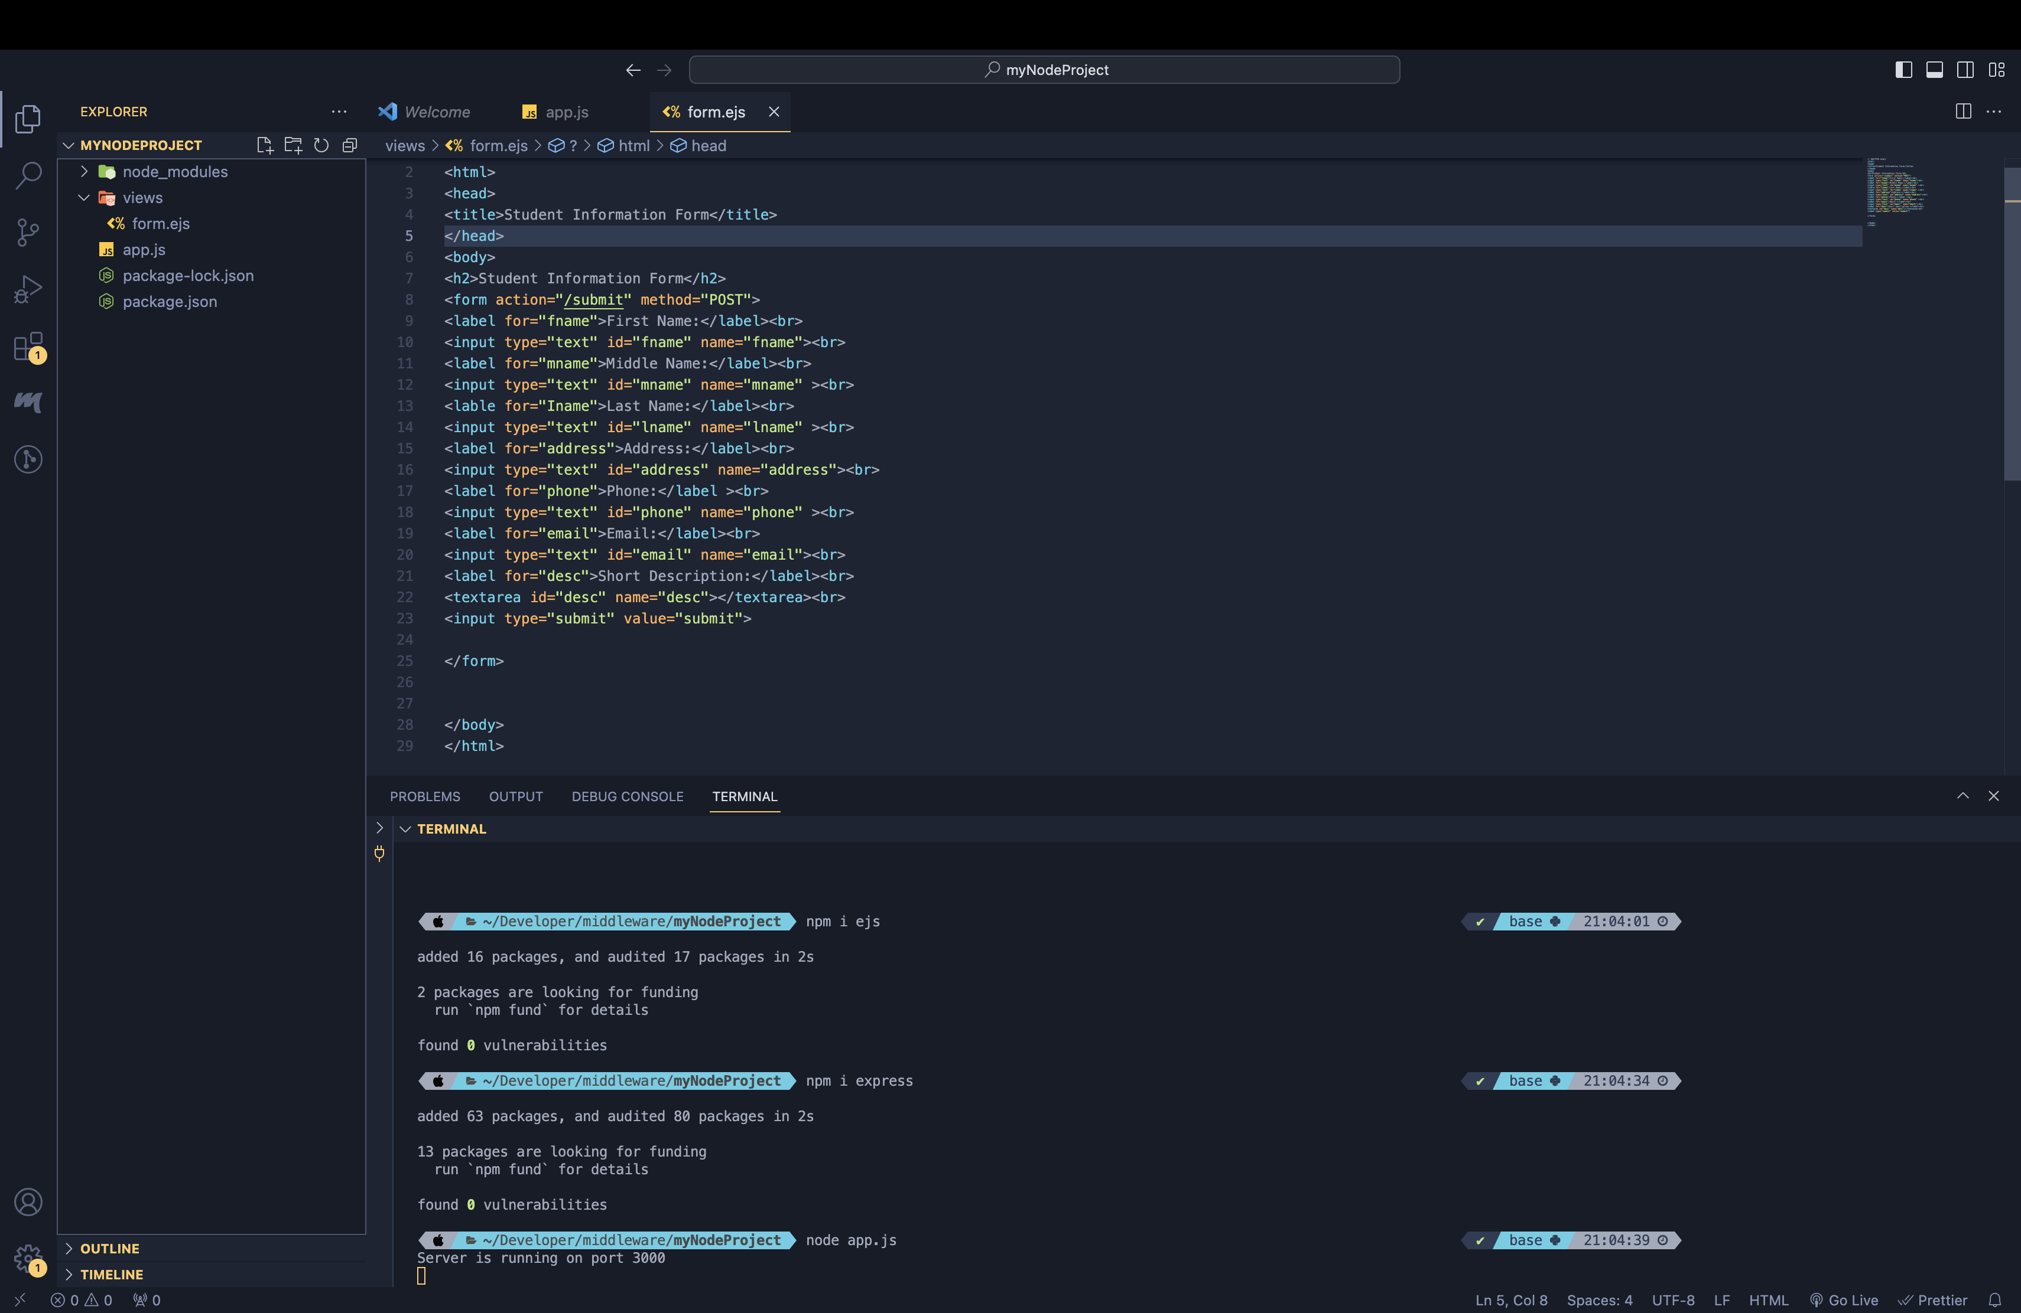

**Screenshot 5**: form.ejs file open in the text editor, displaying the HTML code for the student information form.

Form Submission Handling in app.js

**Screenshot 6**: app.js file showing the added code for serving the form and handling form submissions.

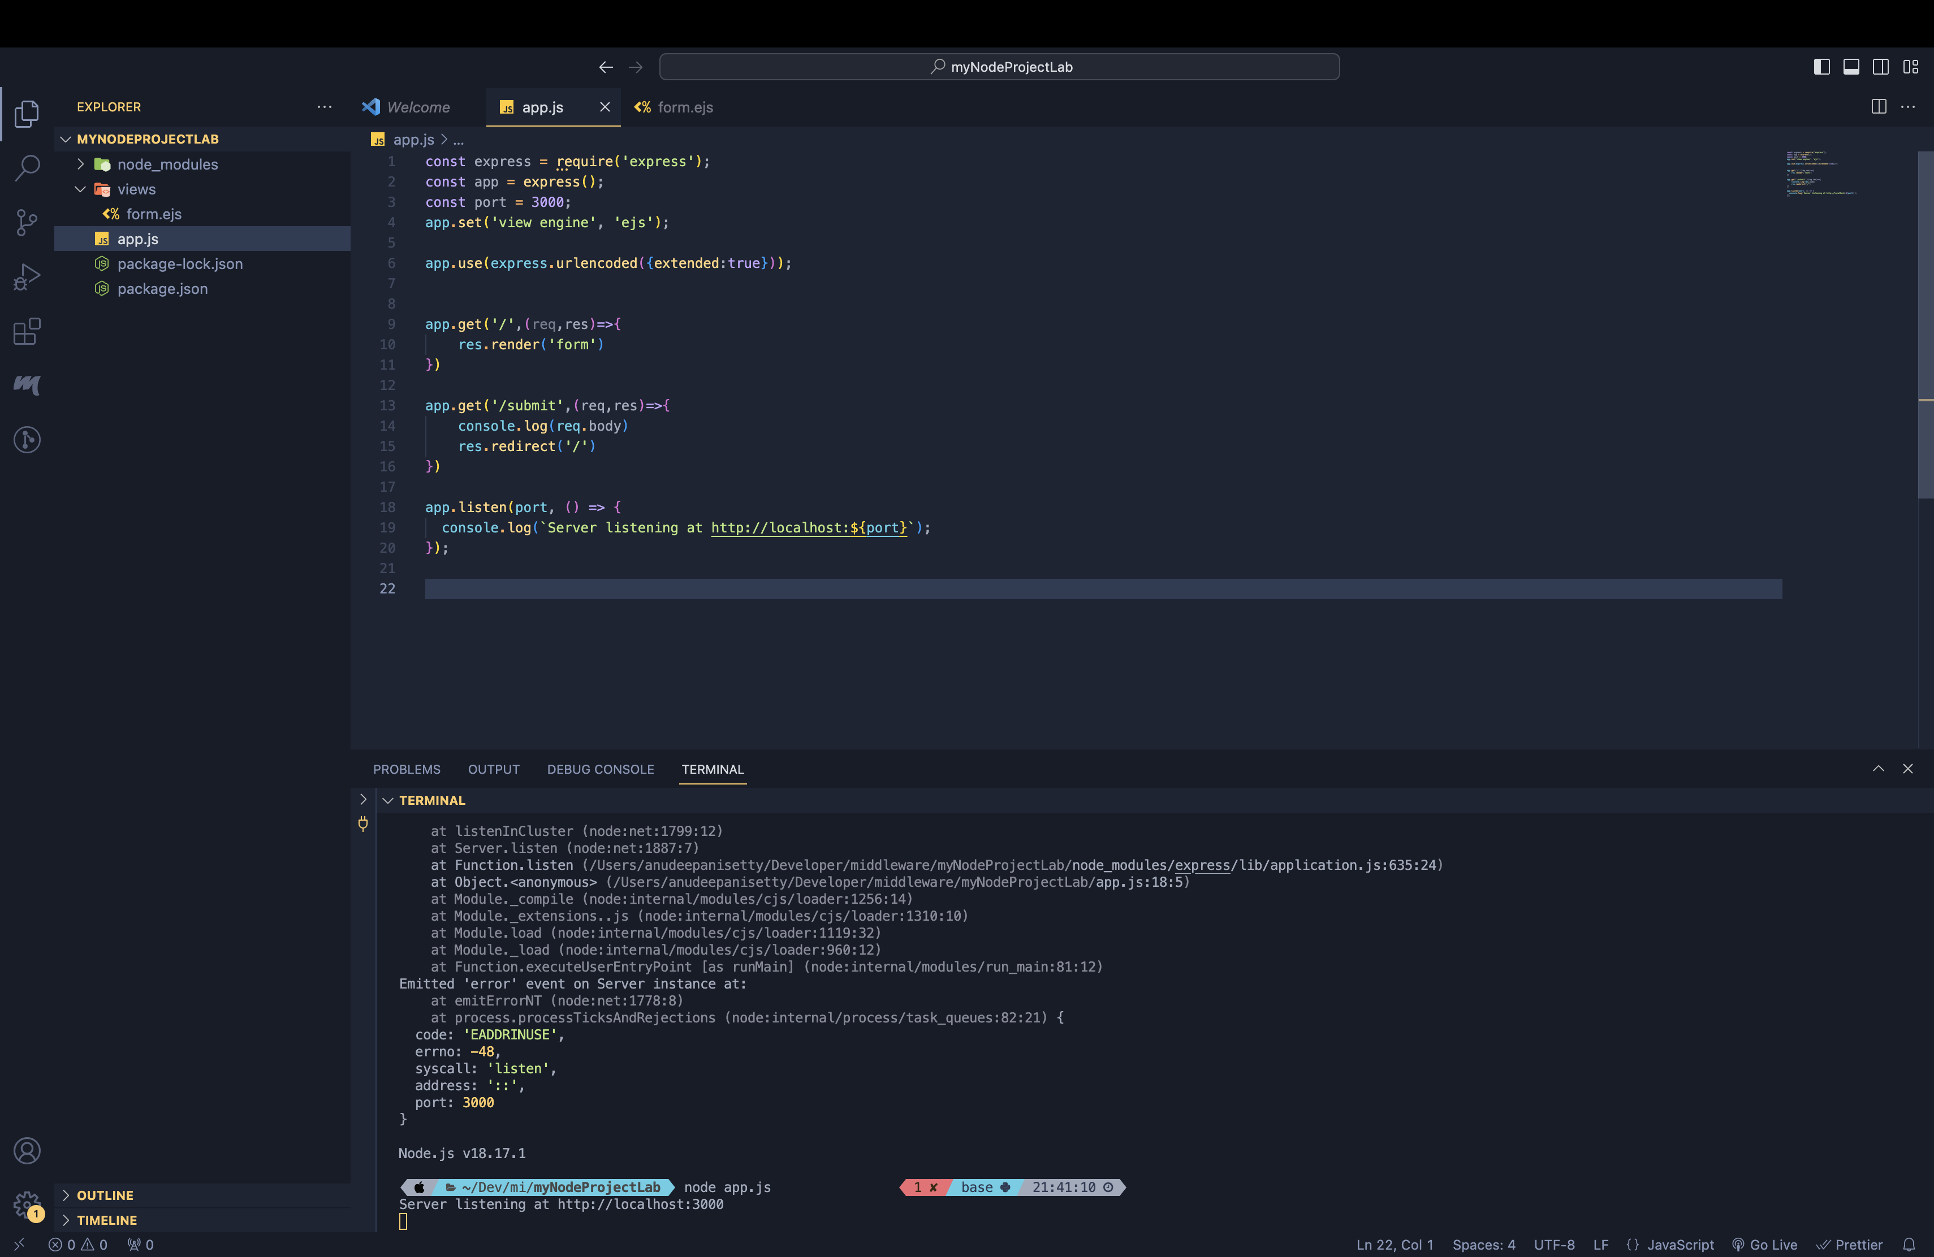

Running Node.js Server

**Screenshot 7**: Terminal executing the node app.js command to run the Node.js application.



**Screenshot 8**: Web browser displaying the student information form at <http://localhost:3000>.

